Scoring Basics

Minimum (to go out) - a combination of chows and pungs of different tiles


One score - No pongs or no flowers, or the right flower or right wind or one of the dragons, or not taking any discards
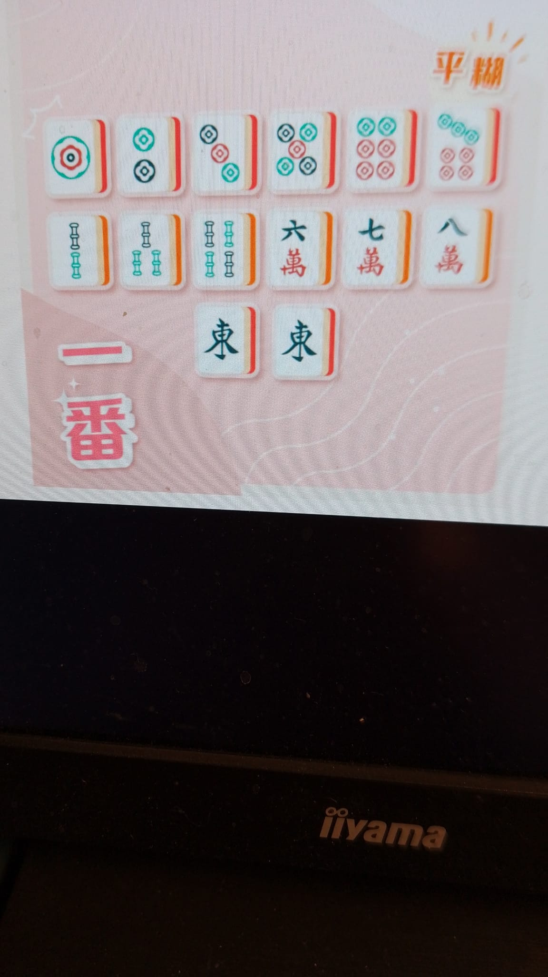

Two scores - Correct flowers and wind, No pongs with a collection of either right wind or flower, or a collection of the 4 flowers or seasons



Three scores - all pongs and chows of the same tiles with wind or dragon as Mahjong. Or all pongs of different tiles with wind or dragon as Mahjong. Or once collect seven flowers and seasons in sequence
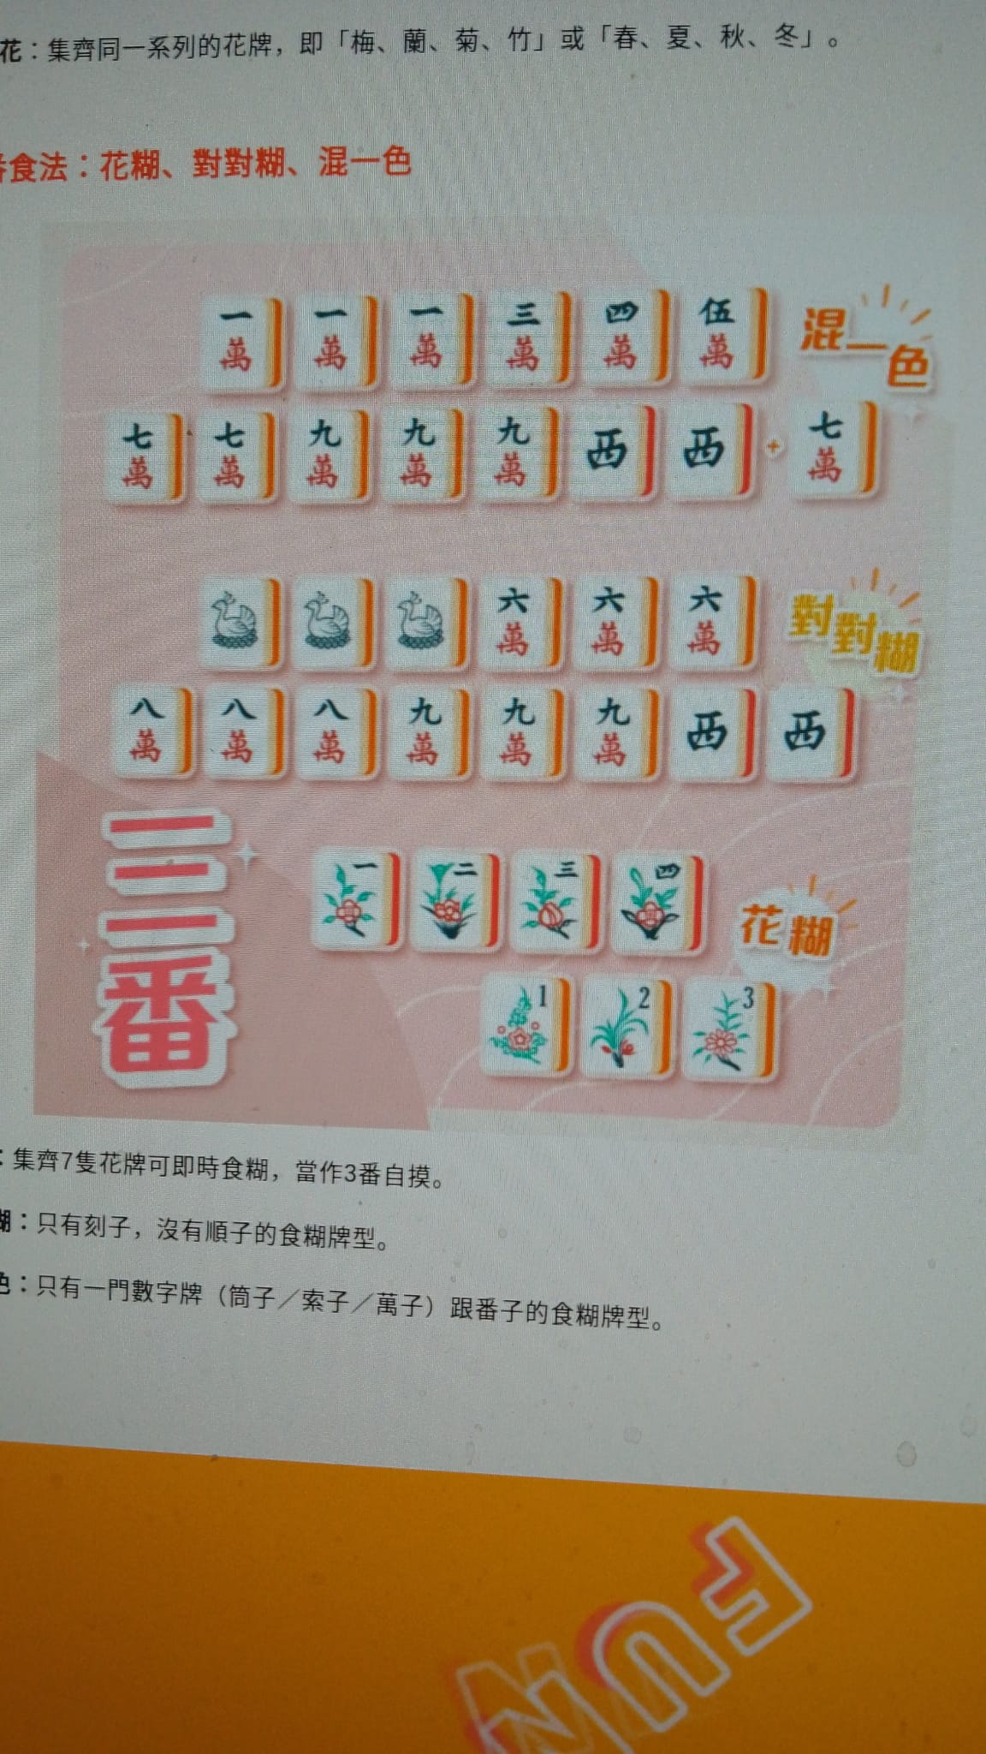
Five - collect all dragons including a pair as Mahjong
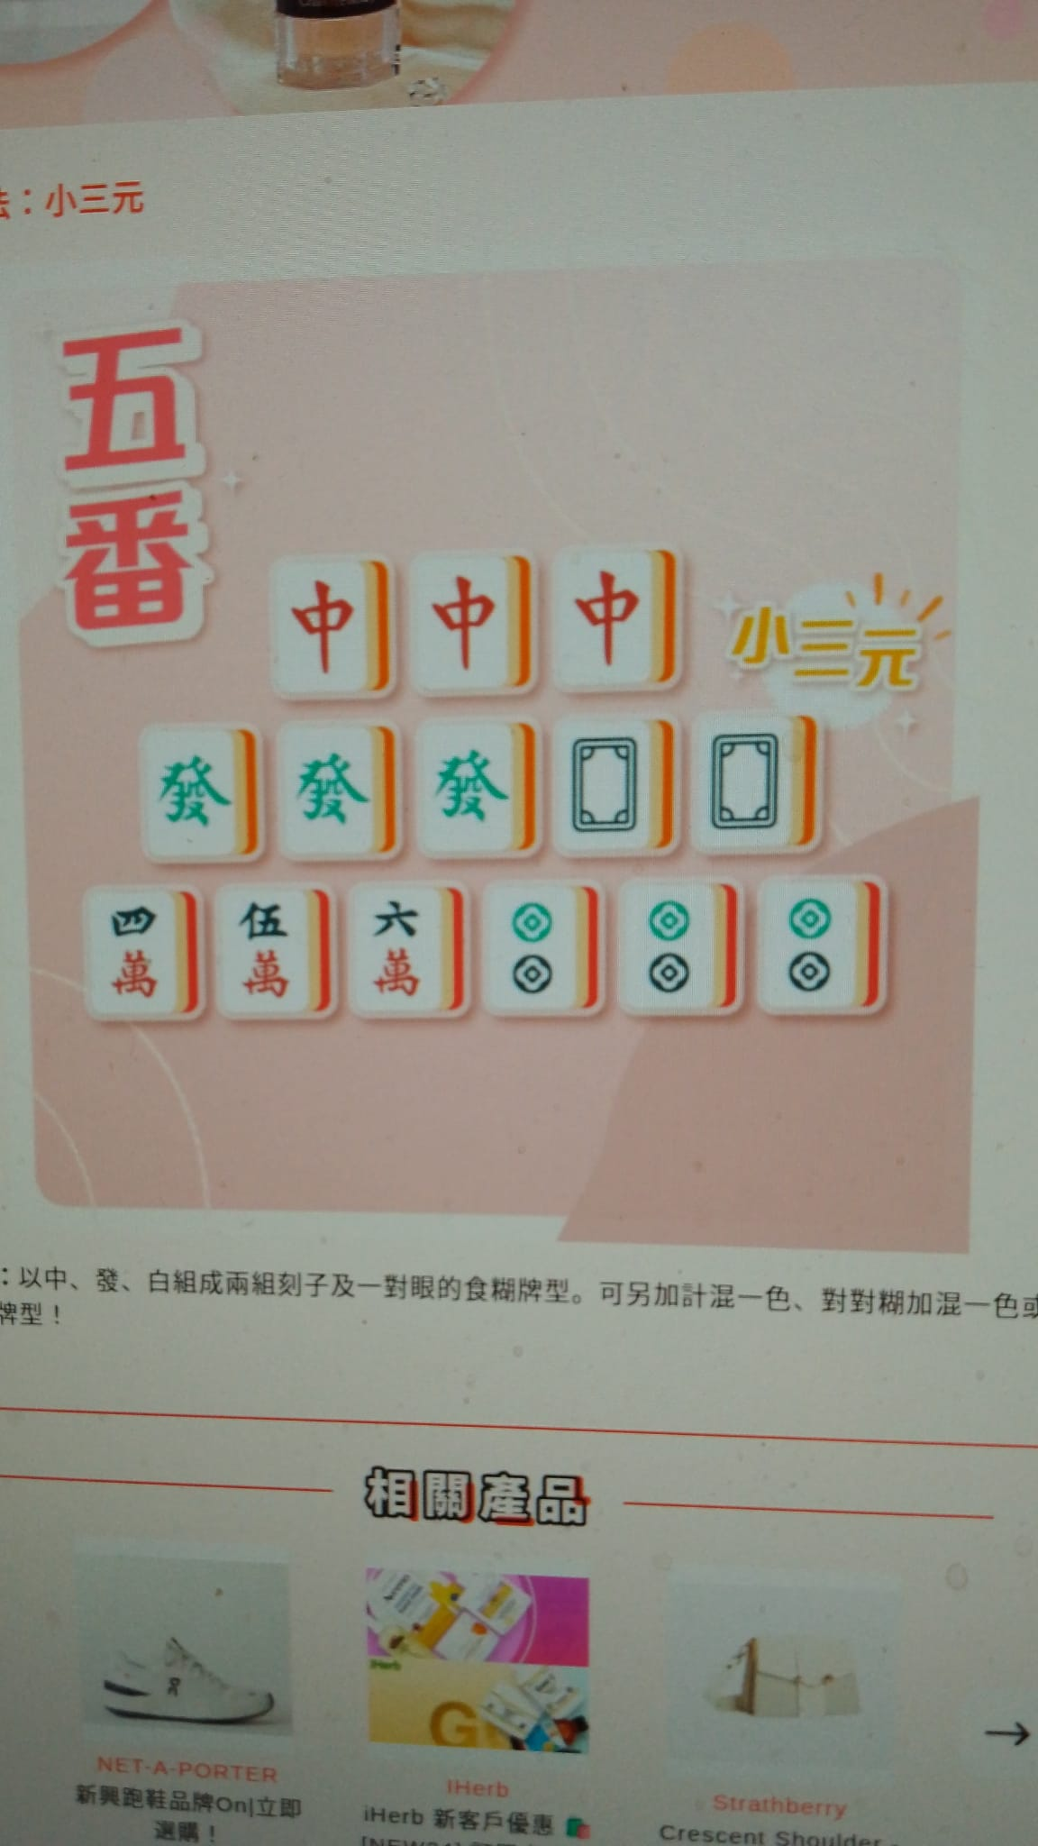

Six scores -all wind tiles including a pair as majong

Seven scores- all identical tiles including the Mahjong

Eight scores- The difference between this and five scores is that all the dragons are in three ; Or three pairs of Kong; Or collect all eight flowers and seasons tiles

Ten scores- 1 to 9 sequential of the same tiles including the Mahjong; Or no 1 and 9 tiles pongs ( can be of different tiles); or All winds and dragons

The overriding rules are;
- Player who discards the tile to let another player win will pay double;
- Self pick will double the scores and
- Where appropriate, when the player has displayed nine tiles and he wins by picking a discarded tile, the one who let the player wins will have to pay for the other two too

